**National Cranberry Cooperative Case Study**

Key issues that are to be solved by Schaeffer:

When it comes to RP1 there are few issues that are to be addressed by Schaeffer. One among those issues is the overtime costs. Even though the **overtime costs were higher** than expected in the last fall, the growers were still upset due to the increased waiting times for unloading process. The potential cause of this issue lies in scheduling the work force. To solve this issue NCC can fire up the RP1 operation on peak days by running two shifts - one from 7:00 to 3:00 and second from 3:00 to 11:00. The second issue that is to be addressed is that trucks has to **wait for longer times** to unload their content. The potential cause of this issue is holding bins are full and not able to accommodate the incoming load and to solve this issue some of the dry berry bins should be used to store the wet berries as it is expected that wet berries harvest will increase in the upcoming season and also new dryers should be purchased to increase the capacity of the RP1. One more issue is that light meter system for colour grading should be installed which costs around $40000. Potential cause for this is that sometimes 2B graded berries are mistaken for grade 3 berries.

**Process Flow**

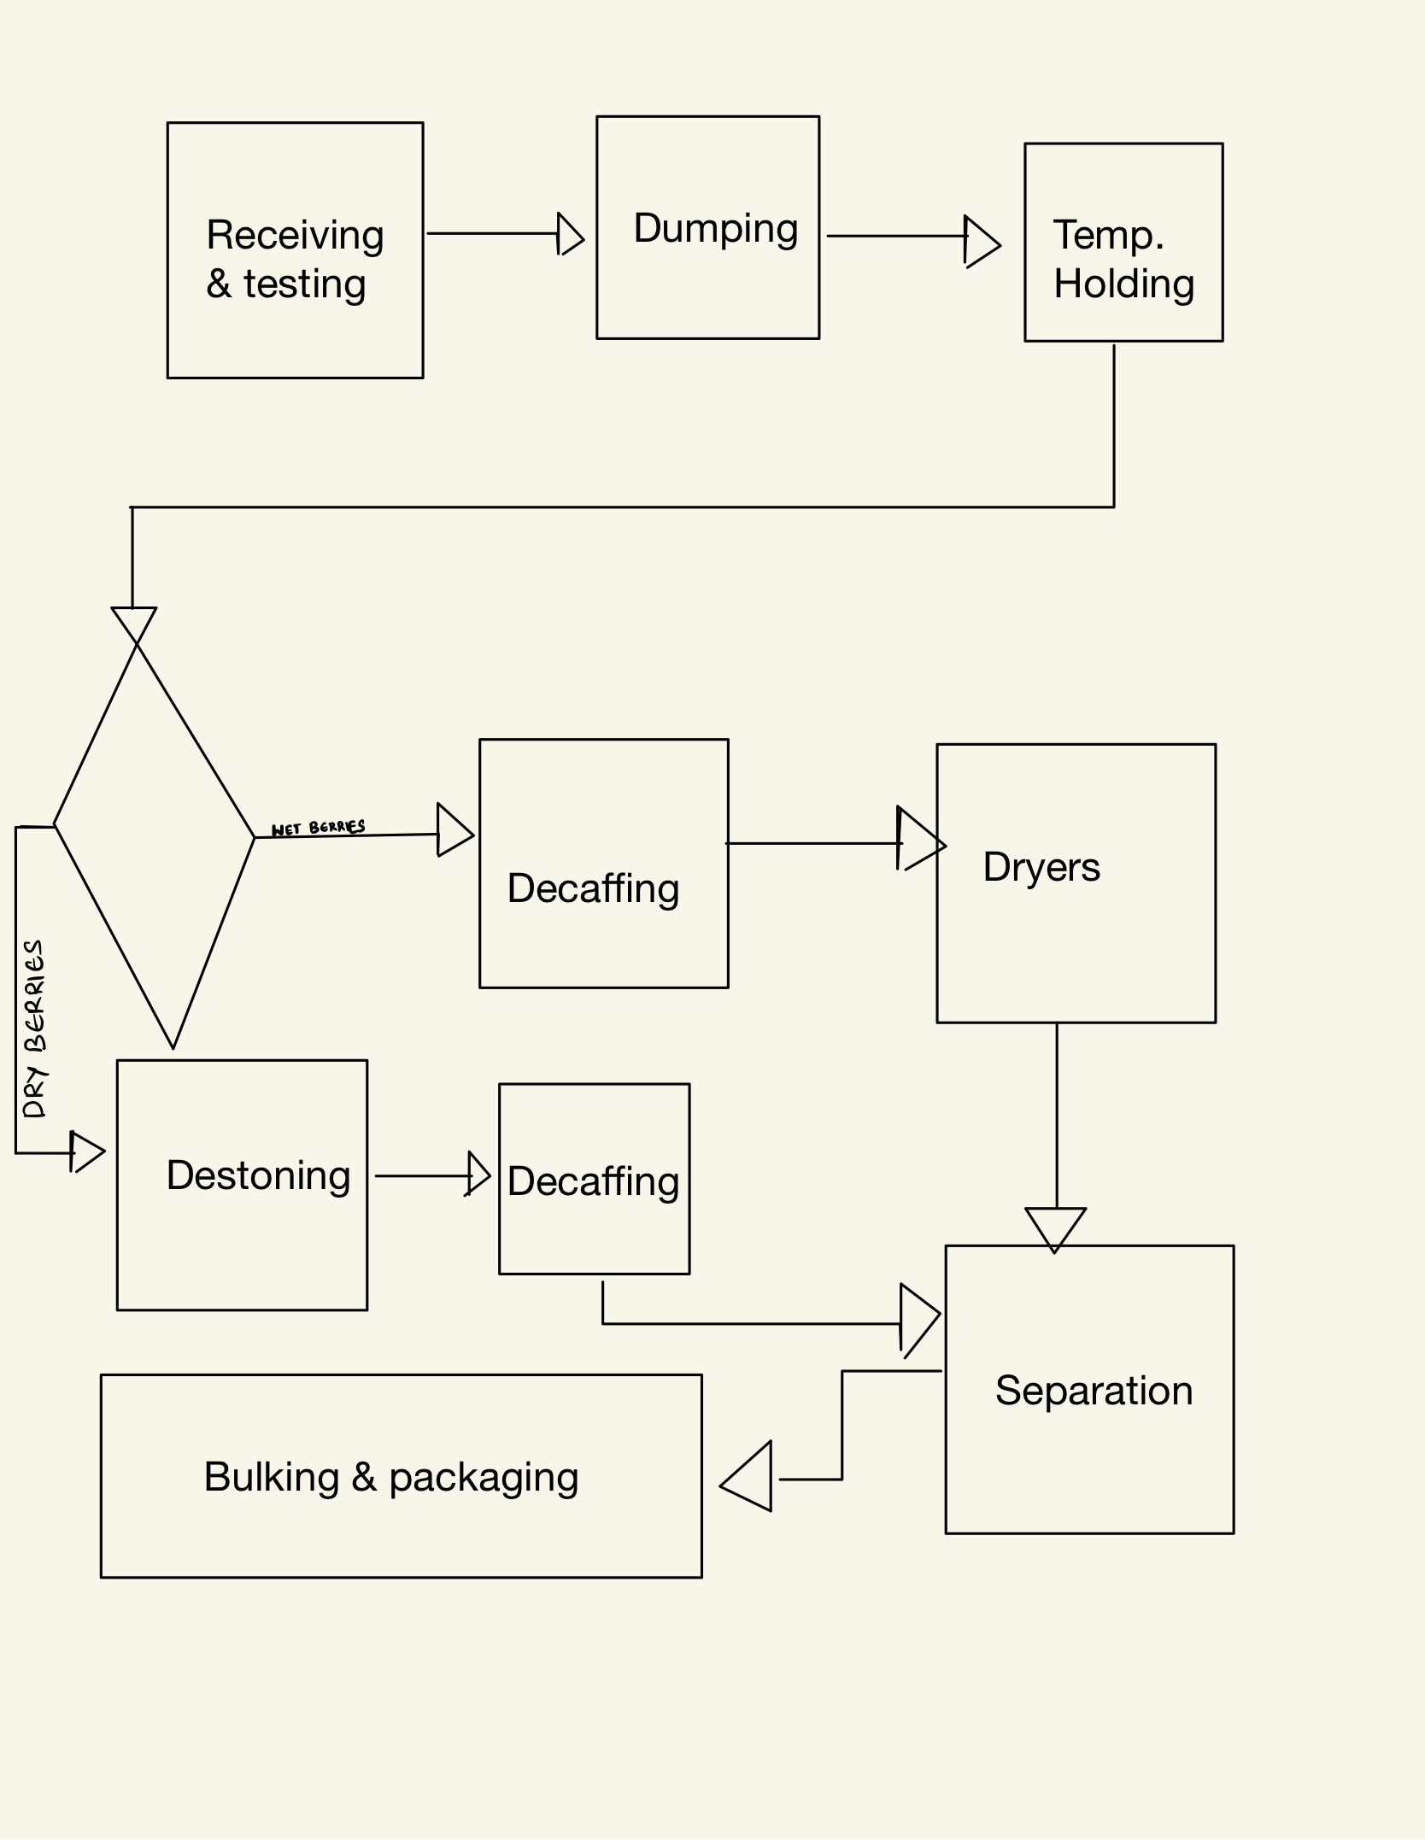

**No of Resources and Total Capacity:**

Receiving and Testing:

Resources Capacity

Trucks 75 bbls / hr

Temporary Holding:

Resources Capacity(bbl/hr)

Holding bins(1-16) 4000

Holding bins(17-24) 2000

Holding bins(25-27) 1200

Destoning:

Resources Capacity (bbl/hr ) No. of resources

Destoners 4500 3

Dechaffing:

Resources Capacity (bbl/hr ) No. of resources

Dechaffing 4500 3

Drying:

Resources Capacity (bbl/hr ) No. of resources

Dryers 600 3

Separation:

Resources Capacity (bbl/hr ) No. of resources

Separators 1200 3

Capacity bottleneck can be defined as a bottleneck which creates a problem in process flow by hindering its capacity. In the above scenario bottleneck can take place anywhere in the process flow. Based on the information provided, it is evident that bottleneck takes place with wet berries in drying process. Reason behind that is berries come at faster pace compared to berries that leaves after processing. Similarly, bagging is another root of bottleneck. It will lead to much larger problem in the following years because wet berries are estimated to increase that will eventually have to be processed. In addition, bottleneck can also take place in temporary holding bins since incoming berries during peak time is much higher than capacity of the bins. It happens because the rate of incoming berries is higher compared to the rate of outgoing berries after the processing this leads to long waiting times for trucks in unloading.